**Computer Network Lab**



**Lab Task 12**

**Submitted by**

**Name:** Fatima Tul Zahra

**Roll No:** Bsdsm-f22-017

**Section:** 5A

**Program:** Data Science

**Submitted To**

**Sir** Rasikh

***Difference between vlan and Inter vlan routing***

|  |  |  |
| --- | --- | --- |
| **Aspect** | **VLAN** | **Inter-Vlan routing** |
| **Definition** | VLANs are logical networks that partition a physical network into multiple virtual networks | Inter-VLAN routing is necessary for communication between devices on different VLANs. |
| **Communication** | Devices within the same VLAN can communicate directly. | Devices in different VLANs cannot communicate directly; they require a router or Layer 3 switch. |
| **Layer of Operation** | Operates at **Layer 2** (Data Link Layer) of the OSI model. | Operates at **Layer 3** (Network Layer) of the OSI model, as it involves routing between networks |
| **Broadcast Domain** | Each VLAN is a separate broadcast domain. | Inter-VLAN routing connects multiple broadcast domains. |
| **Configuration** | VLANs are configured on switches. | Inter-VLAN routing requires configuring interfaces on a router or Layer 3 switch. |

***Structure:***

**Vlan:**

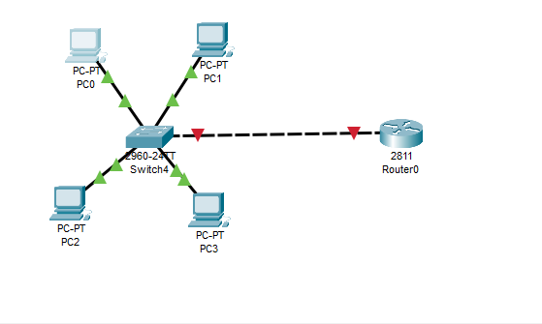

**Commands:**

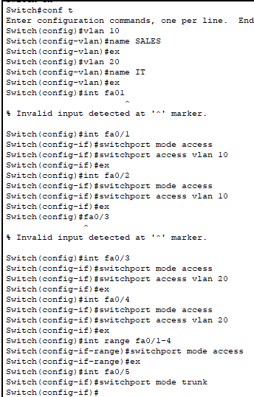

**Inter-vlan commands:**

